13.69: a)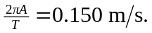 b) 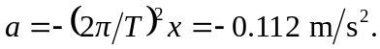 The time to go from equilibrium to half the amplitude is 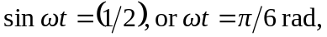 or one-twelfth of a period. The needed time is twice this, or one-sixth of a period, 0.70 s. d)